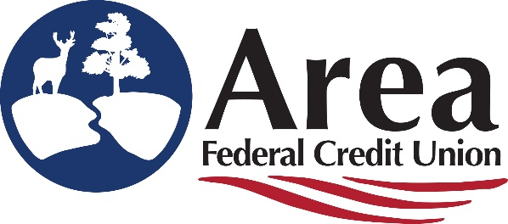

Area Federal Credit Union Scholarship Application 2024
Area Federal Credit Union (Area FCU) understands the importance of higher education. In order to encourage its pursuit, we will offer five (5) $1,000 scholarships for the 2024-2025 academic school year to Area FCU members attending a two- or four-year post-secondary accredited college or university or a technical/vocational school. Full-time employees of Area FCU are ineligible.
Who is Eligible?
- Applicants must be a member of Area Federal Credit Union (Prior to 2024).
- Be the primary member on your account which is in good standing.
- Students must be planning to attend:
  - An accredited college or university or technical/vocational school in the fall upon high school graduation.
  - Be currently enrolled in an accredited college or university or technical/vocational school.
  - An accredited college or university or technical/vocational school.
- Students must be in good standing with the school in which they are enrolled or have recently graduated from and have a GPA greater than 2.5.

How Are Recipients Selected?
- Recipients of an Area Federal Credit Union Scholarship are selected on a number of criteria, including:
- Personal Achievement
- Extracurricular Activities and Employment
- Credit Union Services
- Essay

- Judging will be completed by impartial judges chosen by Area FCU. Judges decisions are final.

Scholarship funds will be paid directly to the institution which the scholar is enrolled in.
Application deadline: Monday April 15, 2024
Area Federal Credit Union Scholarship Application 2024
Name __________________________________________ Credit Union Member: Yes No
Address _____________________________ City _______________State ___________ Zip ________
Email Address ______________________________________________________________________
Phone Number __________________________________Cell Phone___________________________
High School_________________________ Graduation Date__________ HS Cumulative GPA_______
Institution Planning to Attend: _________________________________________________________
Expected Field of Study/Declared Major: ___________________ Full-ride scholarship? Yes___ No ___
 | 4 yr. College or University |  | 2 yr. Community or Junior College |  | Vocational/Technical School

What will your class status be in the fall of 2024?
 | Freshman |  | Sophomore |  | Junior |  | Senior
How did you hear about the Area FCU Scholarship? (Website, school, social media, other) _______________________________________________________________________________
Sworn Statement
I declare the attached essay is my original work, and all other personal information is true. I understand all submitted materials become the property of Area FCU. I further understand any statements or comments found to be invalid will disqualify my application in the selection process. I agree to cooperate with Area FCU in promotional activities related to the scholarship competition and, should I be selected a recipient, give them permission to use my name and photo in promotional activities.

Authority of Area FCU
Area FCU has the authority to amend any of the above rules to ensure fairness awarding the scholarships. Questions regarding the scholarship should be forwarded in writing to: Marketer, Area FCU, PO Box 1495, Aberdeen, SD 57402-1495 or emailed to leadership@areafcu.org.

I certify that everything I have stated on this application and any attachment is true.
Applicant Signature | Date
I give permission to release my full name to the media should I receive this scholarship.
Applicant Signature | Date
Signature of Parent/Guardian (If under 18 years of age at time of application)

Area Federal Credit Union Scholarship Application 2024
Please answer the following questions on a separate page. Please do not include your name on the separate page.

- I am currently attending: High School / University / College / Junior College / Technical / Vocational
- Personal Achievements:
- Extracurricular Activities and Employment:
- What Credit Union Services Do You Have:
- Share Account (Savings Account)
- Share Draft Account (Personal Checking Account)
- Certificate of Deposit (CD)
- Online Banking (It’s Me 247)
- Debit/ATM Card
- Loan Product(s)

- Essay – 500 words or less:
Essays must be typed and grammatically correct. Please do not put your name on the essay page. Area Federal Credit Union is dedicated to helping members grow, please share:
- Tell us how you became a member with Area Federal Credit Union and why you like banking here?
- What is your career/future goals after college?

Application Deadline is Monday April 15, 2024!

Mail application to: Area Federal Credit Union
Attn: Scholarships
PO Box 1495
Aberdeen, SD 57402-1495
*Must be post marked by Monday April 15, 2024
Email application to: leadership@areafcu.org
OR: Drop off in a sealed envelope at Area FCU - Attn: Scholarships

